# Introduction to Control Systems Lab#01



Control Systems Lab

# Submitted by:

# Maaz Habib

# Registration Number:

**20PWCSE1952**

Section**: C**

# Submitted to:

Dr. Muniba Ashfaq **31st/Jan/2024**

# Department of Computer Systems Engineering University of Engineering and Technology, Peshawar

**Introduction to Control Systems Lab#01**

# Objectives:

* To revise MATLAB
* To go through MATLAB Functions

# Statement:

Explain the MATLAB functions below.

# Functions:

1. **Roots**

**Syntax:** r = roots(p)

**Purpose:** Returns the roots of the polynomial for a represented vector.

**Example:**

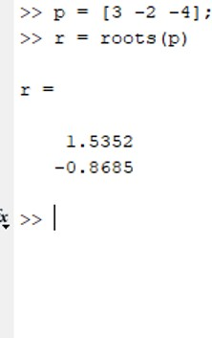

# Poly

**Syntax:** r = poly(r)

**Purpose:** Returns the coefficients of the polynomial.

**Example:**

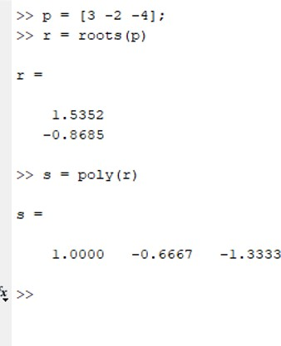

# Polyval

**Syntax:**

y = polyval(p,x)

[[y,delta] = polyval(p,x,S)](https://www.mathworks.com/help/matlab/ref/polyval.html#d126e1255988) [y = polyval(p,x,[],mu)](https://www.mathworks.com/help/matlab/ref/polyval.html#d126e1256021)

[[y,delta] = polyval(p,x,S,mu)](https://www.mathworks.com/help/matlab/ref/polyval.html#d126e1256031)

**Purpose:** Evaluates the polynomial at each point in x. The argument p is a vector of length n+1 whose elements are the coefficients of nth-degree polynomial.

**Example:**

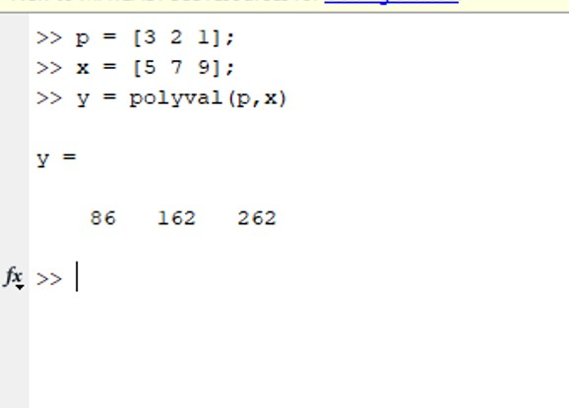

# tf

**Syntax:**

[sys = tf(numerator,denominator)](https://www.mathworks.com/help/control/ref/tf.html#d126e189402) [sys = tf(numerator,denominator,ts)](https://www.mathworks.com/help/control/ref/tf.html#d126e189435)

[sys = tf(numerator,denominator,ltiSys)](https://www.mathworks.com/help/control/ref/tf.html#d126e189476) [sys = tf(m)](https://www.mathworks.com/help/control/ref/tf.html#d126e189500)

**Purpose:** Creates real-valued or complex-valued transfer function models, or converts dynamic system models to transfer function form. In brief, it creates a system.

**Example:**

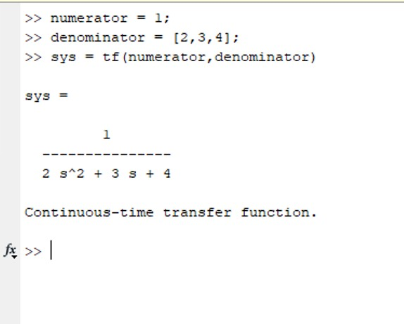

# Conv

**Syntax:** [w = conv(u,v)](https://www.mathworks.com/help/matlab/ref/conv.html#d126e274484)

**Purpose:** Returns the convolution of two vectors i.e. u and v.

**Example:**

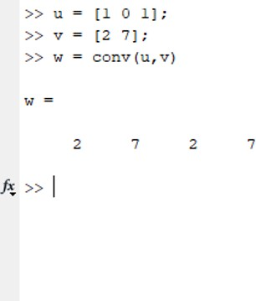

# Step

**Syntax:** [y, TOut] = step(sys)

**Purpose:** Provides the response of the system within the limit of the input.

**Example:**

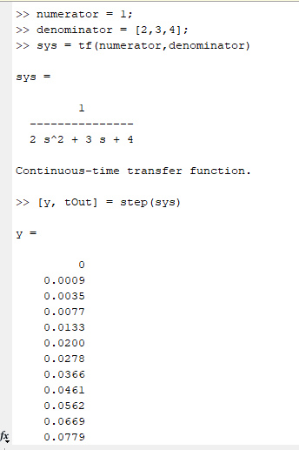

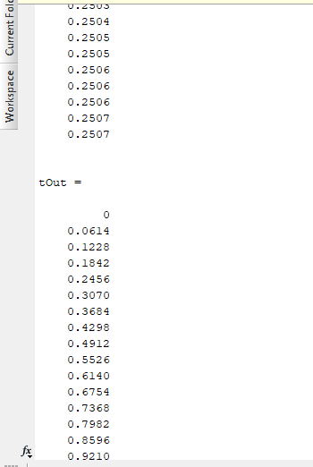

# Impulse

**Syntax:** [y, TOut] = impulse(sys)

**Purpose:** Provides the response of the system (output response) for the exact input value given.

**Example:**

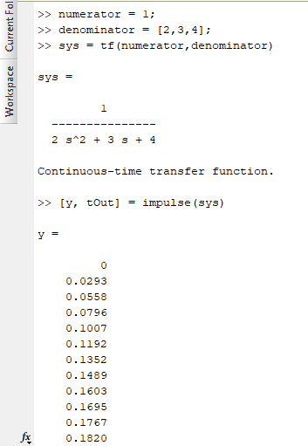

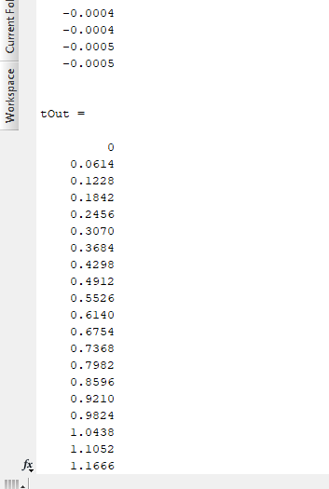

# Series

**Syntax:** sys = series(sys1,sys2)

**Purpose:** Connects two model objects in series.

**Example:**

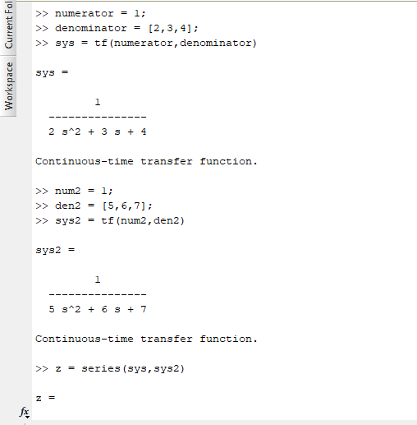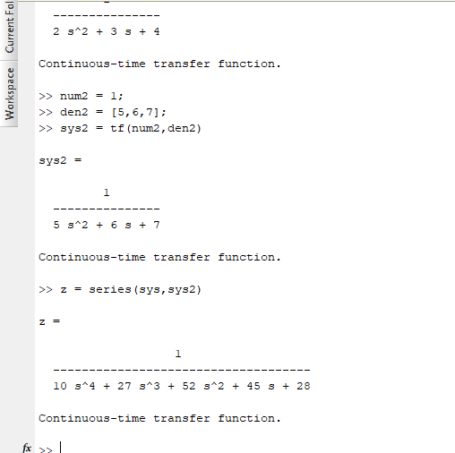

# Feedback

**Syntax:** sys = feedback(sys1, sys2)

**Purpose:** Returns a model object sys for the negative feedback interconnection of model objects sys1 and sys2.

**Example:**

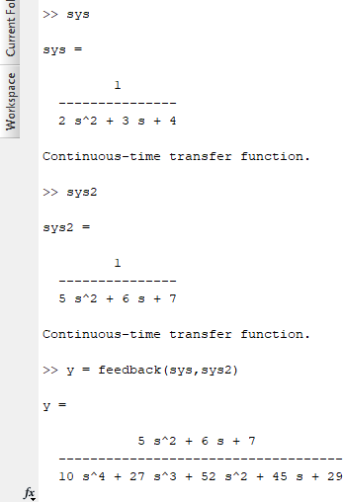

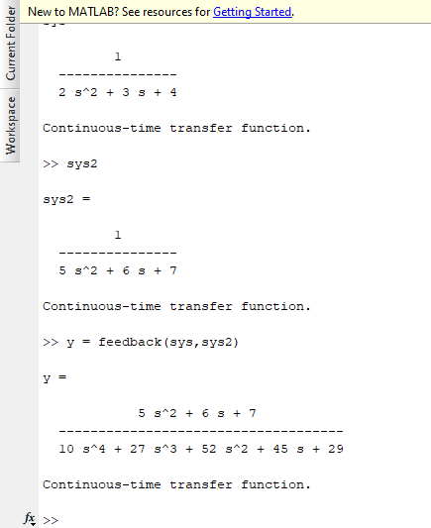

# Residue

**Syntax:**

[r,p,k] = residue(b,a)

[b,a] = residue(r,p,k)

**Purpose:** finds the residues, poles, and direct term of a Partial Fraction Explansion of the ratio of the two polynomials.

**Example:**

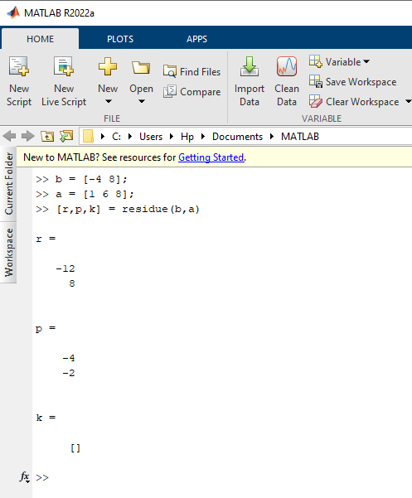

# Poles

**Syntax:** P = pole(sys)

**Purpose:** Returns the poles of a dynamic model system to show whether the system is stable or unstable.

**Example:**

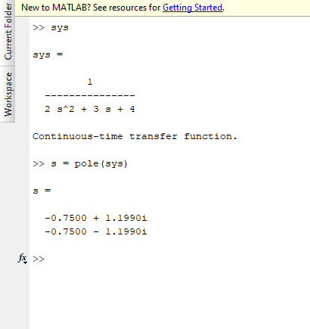

# Pzmap

**Syntax:** [[p,z] = pzmap(sys)](https://www.mathworks.com/help/ident/ref/lti.pzmap.html#d126e170314)

**Purpose:** Creates a pole-zero plot of the continuous or discrete-time dynamic system model i.e. sys.

**Example:**

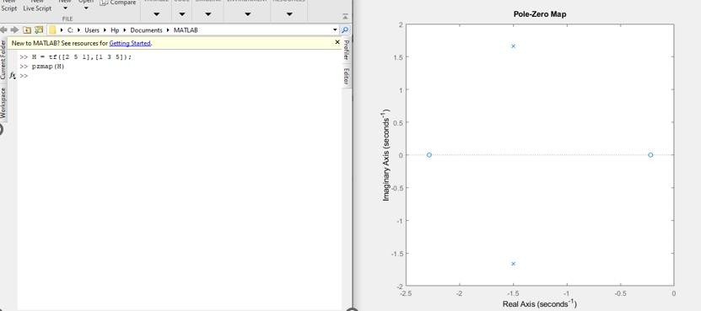

# Conclusion:

In this lab report, we have studied MATLAB functions . Most of these functions are related with the creation of system models and the system’s response.